**Extent report Configuration**

ExtentReports is an open-source reporting library useful for test automation. It can be easily integrated with major testing frameworks like JUnit, NUnit, TestNG, etc. These reports are HTML documents that depict results as pie charts. They also allow the generation of custom logs, snapshots, and other customized details.

Contents

* **Extent report File**
* **Process of Report generation**
* **Configuration with Project**
* **Extent report File**

**Copy Extent.java file from below link and Copy to your base project Application package.**

**\\192.168.10.216\MahiShare\ReportAndMail\Reporting**

**Add below Maven dependency to Your base Project and import references for Extent report.**

<dependency>

<groupId>com.aventstack</groupId>

<artifactId>extentreports</artifactId>

<version>4.1.5</version>

</dependency>

* **Process of Report generation for Tests**

**How exactly Extent report will work!!!**



**Reports are generating by Four steps**

* **Start Test**: Executes preconditions of a test case
* **End Test**: Executes postconditions of a test case
* **Log:** Logs the status of each test step onto the HTML report being generated
* **Flush:** Erases any previous data on a relevant report and creates a whole new report

**StartTest : -**

* **Starting Extent report and Setting environments for extent report.**

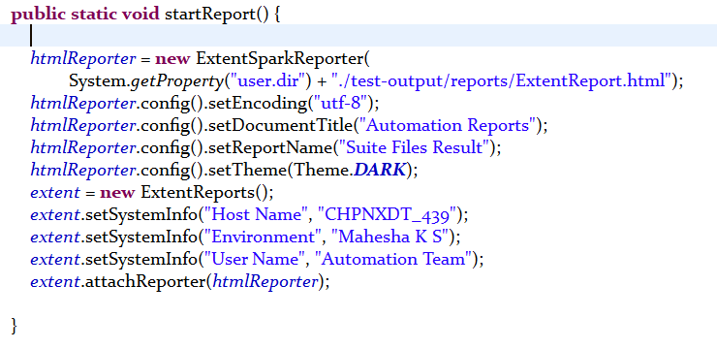

* **Logger initiating for test scripts with the test name.**

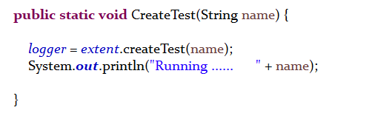

**EndTest : -**

* **Its totally depends on Logger status**
* **If test fails it will take screen shot and proceed for next test.**

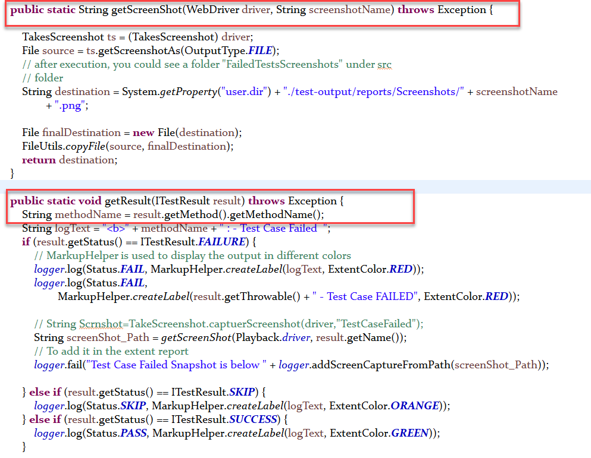

**Log:**

* **Status of test Pass, Fail and Skip**
* **As per the status it will collect the log with respected color as shown below**

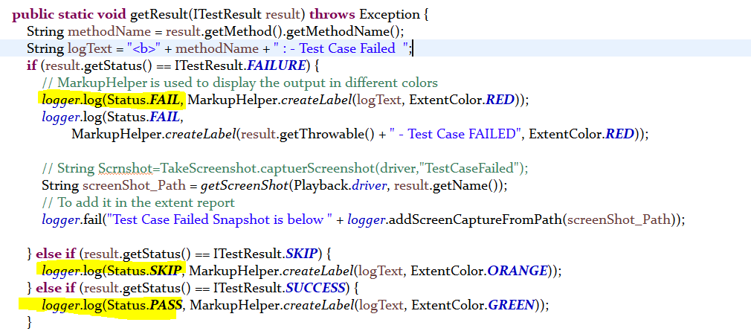

**Flush:**

* **At the end of the test We need to use Flush to generate new Extent report.**

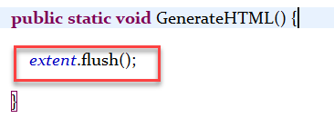

**Let’s See How We Configure Extent Report With our Test Scripts**

* **Configuration with Test scripts**

1.**We should call CreateTest Function from ExtentReport class, as a First line of the scripts.**

ExtentReport.CreateTest(Thread.currentThread().getStackTrace()[1].getMethodName());

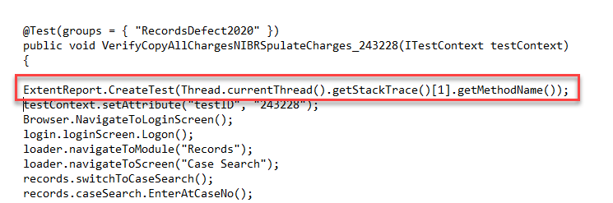

2. **At the end of the scripts We must switch to any Existing Window or else it will lose Continuity of the report, NavigateToModule will switch to Main window So we can use.**

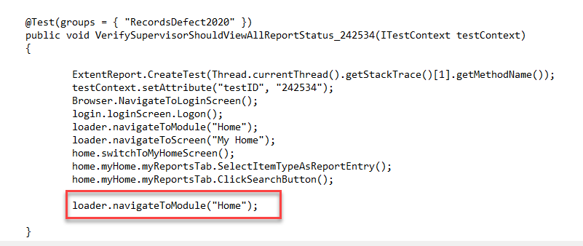

**3. AfterMethod function we Should use as Below to get Each test Results.**

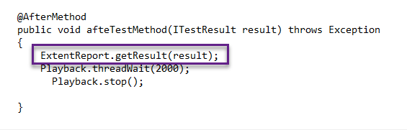

**4. AfterSuite function we Should use as Below to Generate report.**

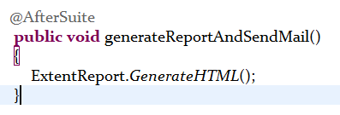

5. After Flush, reports will generate Automatically inside the folder path we mentioned.

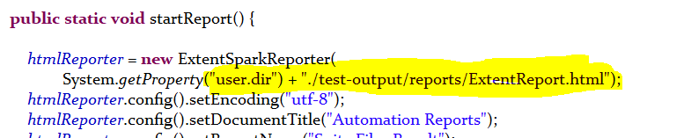

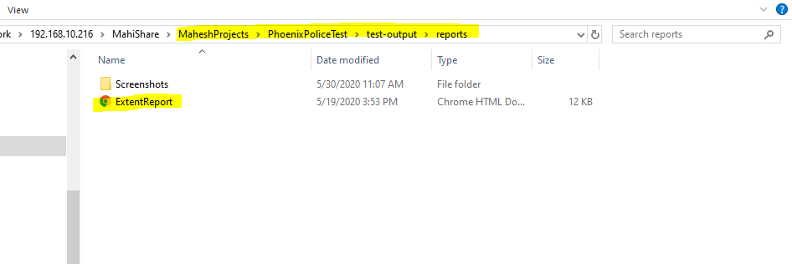

**6. Extent report will Generate as shown with test case name.**

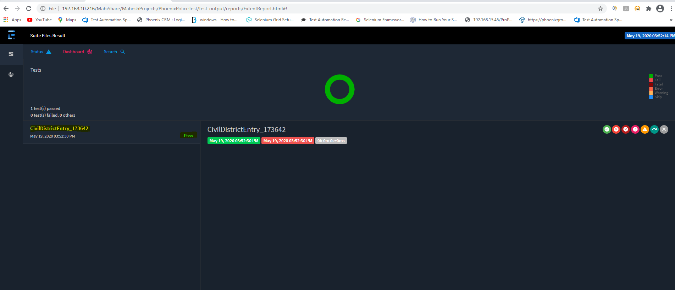

End

**Thanks**

**Mahesha K S**